**Practical 3 : Write a shell script to display multiplication table of given number.**

echo "My name is nakul dhrangadhariya"

echo "My enrollment number is 92410103118"

echo "My class is EC5-C"

echo "Enter a number to display its multiplication"

read n

if ! [[ "$n" =~ ^[0-9]+$ ]]; then

echo "Invalid input!!"

exit 1

fi

echo "Multiplication table for $n"

for ((i = 1; i <= 10; i++)); do

echo "$n x $i = $((n * i))"

done

output :

My name is nakul dhrangadhariya

My enrollment number is 92410103118

My class is EC5-C

Enter a number to display its multiplication

11

Multiplication table for 11

11 into x 1= 11

11 into x 2= 22

11 into x 3= 33

11 into x 4= 44

11 into x 5= 55

11 into x 6= 66

11 into x 7= 77

11 into x 8= 88

11 into x 9= 99

11 into x 10= 110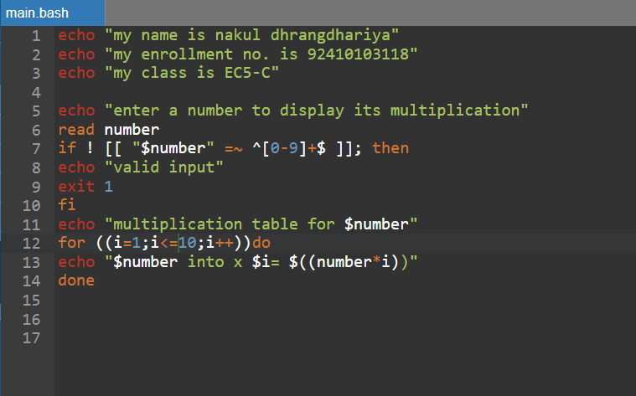

Figure 3.1 : program to print table of given number

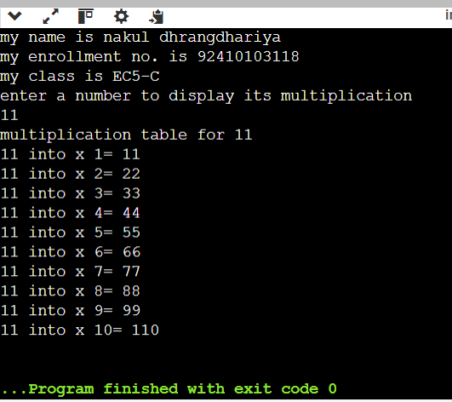

Figure 3.2 : output of table printing program